Assignment 8.1:

Create emp_sal_data

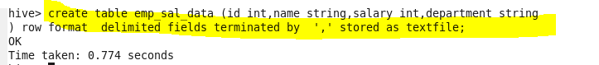

Load the data in to the table

Dataset :

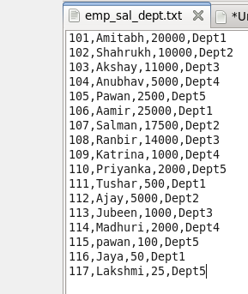

Load data in to above created table:



Verify data in the table:

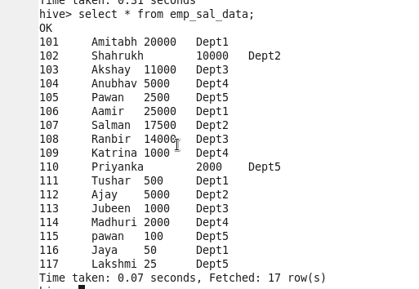

Get a list of employees who receive a salary less than 100, compared to their immediate employee with higher salary in the same unit 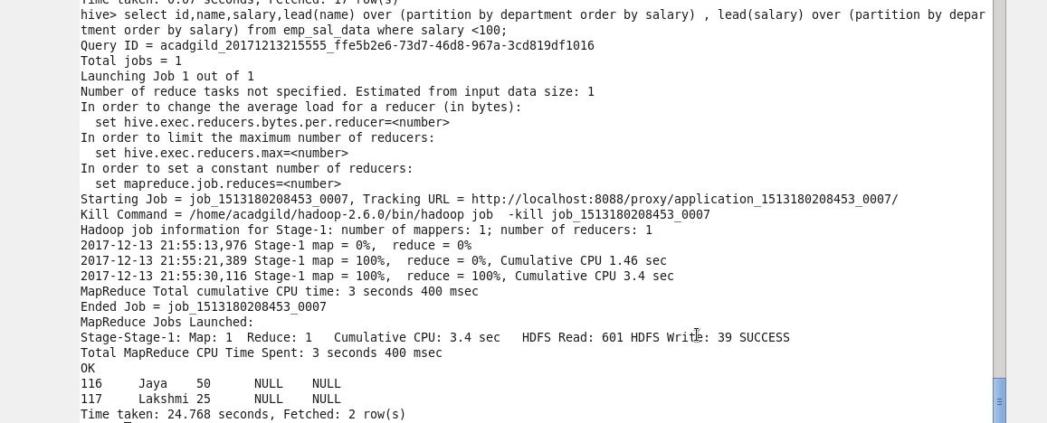

2. List of all employees who draw higher salary than the average salary of that department

Create a view to with average salary of the employees by department



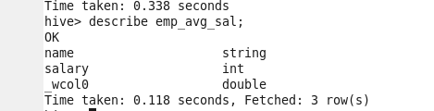

Here _wcol0 has avg salary of the department

Execute the query on the above created view to get List of all employees who draw higher salary than the average salary of that department

